**DPG Review Policy**

This document lays out the policies that govern the review process of DPG applications.

Nomination Policy

Application Review Policy

DPG Registry Moderation Policy

DPG Status Renewal Policy

Spam Policy

Issue Resolution Policy

### Nomination Policy

* Owners of digital solutions who wish to get their solution recognized as a Digital Public Good (DPG) must nominate their solution by submitting a DPG application (application).
* Application can be created and submitted through the DPGA webapp at [app.digitalpublicgoods.net](https://app.digitalpublicgoods.net/)
* The set of questions that are asked as part of the application are transparently available [here](https://github.com/DPGAlliance/DPG-Standard/blob/main/standard-questions.md).
* Applications can only be submitted by an authorised representative of the digital solution (the applicant).
* We collect the name & email of the applicant. Email verification is required in order to submit an application.
* Each application is assigned a unique application ID.
* Content of each submitted application is made publicly available & licensed as such via Unilicence.
* The submitted applications can be accessed via their public URLs (URL format: app.digitalpublicgoods.net/a/[ID]) as well as via a PR on [this GitHub repo](https://github.com/DPGAlliance/publicgoods-candidates/pulls).

### Application **Review** Policy

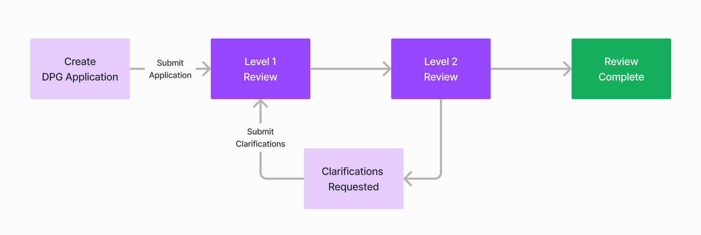

* Each application is assessed against the latest version of the [DPG Standard](https://github.com/DPGAlliance/DPG-Standard/blob/main/standard.md) at time of creating the application.
* Each application is thoroughly reviewed by at least two people from the DPGA review team.
* Application must meet all the requirements of the DPG Standard to become a DPG. If the application fails to meet one or more requirements, they will be declared as “ineligible to be recognized as a DPG at this time.”
* Every review results in a binary decision : DPG or Ineligible.
* Final determination on whether a solution adheres to the DPG Standard will be made by the DPGA Secretariat’s Technical Coordinator.
* A digital solution recognized as a DPG will be listed on the public [DPG Registry](https://digitalpublicgoods.net/registry/) and their listing will also made be available to other databases via an API.
* If required, the reviewers may consult the Community Manager, the Product Manager and domain experts on a case to case basis.
* A reviewer may reach out to the applicant to seek clarifications and/or gather additional information in order to complete their review.
* The applicant will be intimated about the request for clarification via email and the DPGA webapp.
* The applicant must submit clarifications within the time allotted to them by the reviewer.
* If the applicant fails to respond with all requested clarifications within the time allotted to them, then the application will be automatically declared Ineligible.
* During the time for which clarifications are requested and a final review decision is taken, the solutions will be listed on the registry as a “nominee”.

Working on this table.

| **Stages of Application** | **Created** | **Under Review** | **Waiting for Clarifications** | **Under Consultation** | **Review Complete** |
| --- | --- | --- | --- | --- | --- |
| What happens at this stage? | Solution is screened for open source & SDG relevance | Solutions are screened against the full DPG standard | Solutions appear as DPGs on the registry | Solutions are in the database but not on registry |  |
| Requirements to enter this stage | First 3 indicators | Has completed a nomination form & there is a project contact | Addressed all of the DPG Standard | No response for 30 days |  |
| Nomination form & passing the nomination stage | Completing the review process | Manually moved to inactive - PR open |  |  |  |
| How long does this stage last? | T+7 days | T+21 days | 1 year | Infinitely |  |
| What happens if the requirements aren’t met | Project moves to excluded pipeline | It fails the indicator and applicant is informed | Returns to “new application stage” | Reactivate the application - returns to “new” |  |
| Visible on the registry? | Yes | Yes | Yes | No |  |

### DPG Registry Moderation Policy

* The public [DPG registry](https://digitalpublicgoods.net/registry/) displays all digital solutions that are recognized as DPGs and Nominees.
* Solutions that appear on the registry as DPGs will be notified and invited to use the DPG term, the DPGA icon and the DPG badge to describe the digital solution and to promote their solution and to link to the DPG Registry.
* All of the information available on the DPG Registry is openly licensed and made accessible to any other entity wishing to display it via an API - as such information on the DPG registry may be mirrored or used by any number of other entities.
* On an ongoing basis, DPGs must always be able to demonstrate relevance to the Sustainable Development Goals and use of an approved open license.
* If at any point a DPG is found to no longer use an open license or be relevant to the SDGs, they will be removed from the DPG Registry. To report a DPG that may no longer meet this criteria please email [support@digitalpublicgoods.net](mailto:support@digitalpublicgoods.net).
* A DPG listing can also be removed at the request of the applicant.

### DPG Status **Renewal Policy**

* DPG status is valid for one year from the date of completion of review.
* To ensure that a DPG continues to be in compliance with the latest DPG Standard, they must submit a Renewal application.
* Renewal applications can be created when 45 days or less are remaining before the expiry of DPG status. Renewal application can also be created after the DPG status has expired.
* Renewal applications must be created & submitted via the DPGA webapp.
* Upon a re-review, if the solution is found to be in compliance with the latest DPG Standard, they will be stay listed on the DPG Registry.

### Spam Policy

* Any application that is deemed nonsensical, malicious, irrelevant or in violation of our [Code of Conduct](https://github.com/DPGAlliance/DPG-Standard/blob/main/CODE_OF_CONDUCT.md) will not be reviewed and will be removed immediately.

### Issue Resolution Policy

* Progress and status of review of an application is transparently visible on their public URL (app.digitalpublicgoods.net/a/[ID]) and via the applicant’s dashboard.
* To engage in the public discourse on a submitted application, please interact with us by commenting the relevant PR on [this public GitHub repo](https://github.com/DPGAlliance/publicgoods-candidates/pulls).
* To raise disagreements with a review decision or any other issues related to reviews, please write to us at support@digitalpublicgoods.net